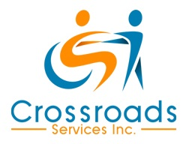

Limited English Proficiency Policy

Individuals who are employed by, or participate in the programs, of Crossroads Services, Inc. are eligible for free competent language assistance services.

This policy is set forth to ensure that all employees and participants of Crossroads Services, Inc. and Crossroads Adult Services have meaningful and equal access to all services and benefits.

Printed Name: ___________________________________________________
(Individual)

Signature: _______________________________________________________
(Individual)

Date: ___________________________________________________________

Printed Name: ____________________________________________________
(Parent/Guardian/Caregiver)

Signature: ________________________________________________________
(Parent/Guardian/Caregiver)

Date: ___________________________________________________________

